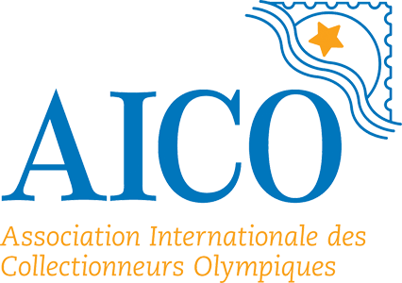

**Call for Expression of Interest**

Organization of World Olympic Collectors’ Fairs for 2025, 2026 and 2027

**World Olympic Collectors’ Fair Background**

The International Olympic Committee supports the Olympic collector movement by granting patronage to different forms of Olympic collector activities as well through the direct assistance of the Cultural and Olympic Heritage Commission. The World Olympic Collectors Fair, which has been an almost annual event since 1994, is an expression of the IOC’s support.

The World Olympic Collectors’ Fairs are excellent opportunities for Olympic enthusiasts to share their combined interests in Olympic history and collecting. The Fair has travelled around the globe visiting past and future Olympic host cities.

The Fair can be organized in any appropriate place, however, this would be an excellent opportunity for museums which are members of the Olympic Museum Network to organize the event. The benefits of holding the Fair are many:

1. Collectors and the public are made aware of the museum’s collections;
2. This is an opportunity for the museum and collectors, who are very often highly knowledge experts in different domains of Olympic history and memorabilia, to exchange information;
3. It provides the environment for the museum to increase its own holdings.

The IOC considers that a primary duty of AICO is organising events such as fairs and exhibitions associated with Olympic philately, numismatics and memorabilia.

The IOC Cultural and Olympic Heritage Commission and AICO are responsible for accepting proposals from entities wishing to host a World Olympic Collectors’ Fair. Currently, we are accepting proposals for Fairs to be conducted in 2025, 2026 and 2027.

1. **Eligible Prospective Organiser**

The Call is open to all organisations/institutions which are in compliance with the regulations of the IOC and Olympic Charter, as well as with all applicable laws and regulations, and who maintain a practice reflecting the principles of good governance at the time of the Event.

**The list of eligible Prospective Organisers includes, but is not limited to:**

1. **Olympic Games Organizing Committees;**
2. **National Olympic Committees;**
3. **International Sports Associations recognized by the IOC;**
4. **Members of the Olympic Museum Network;**
5. **Members of AICO, the International Olympic Collectors Association.**
6. **Application procedure**

The purpose of this Call is to identify eligible candidates to organize the World Olympic Collectors Fair in 2025, 2026 and 2027. To qualify for consideration, Applicants must submit an *EXPRESSION OF INTEREST* by 15 October 2023. This document must include the following information:

1. Fair location (city/country) and duration (dd/mm/yy to dd/mm/yy);
2. Information on main objective/s of the Fair and the relationship of the Fair, if any, to other Olympic/sports celebrations to be held at the same time;
3. Information on any support and/or involvement of the NOC;
4. Main accompanying events and activities planned for Fair participants (e.g. any cultural or social events, tours, etc.);
5. Prospective financial resources.

If there are multiple candidates to host the WOCF in any one year, a competitive procedure will be applied. AICO will initiate a dialogue with all parties to define, in the best interests of the family of Olympic collectors, a schedule of successful candidates.

1. **Expected WOCF Start Dates and Durations**

The Fairs are expected to start not earlier than May/June. The duration of the WOCF should be 3-4 days and include a weekend.

1. **Funding Source**

It is expected that the Organizer will be responsible for financing the WOCF. However, once selected, the Organizer may apply for the financial support from the IOC, based on the assumption that the Fair is a non-profit event.

1. **Submission Requirements**

The complete *EXPRESSION OF INTEREST* should be submitted electronically, in English, to reach the AICO Secretary General Mark Maestrone, not later than **15 October 2023**. The email address is: mark.maestrone@aicolympic.org